1) To find average and grade for given marks.

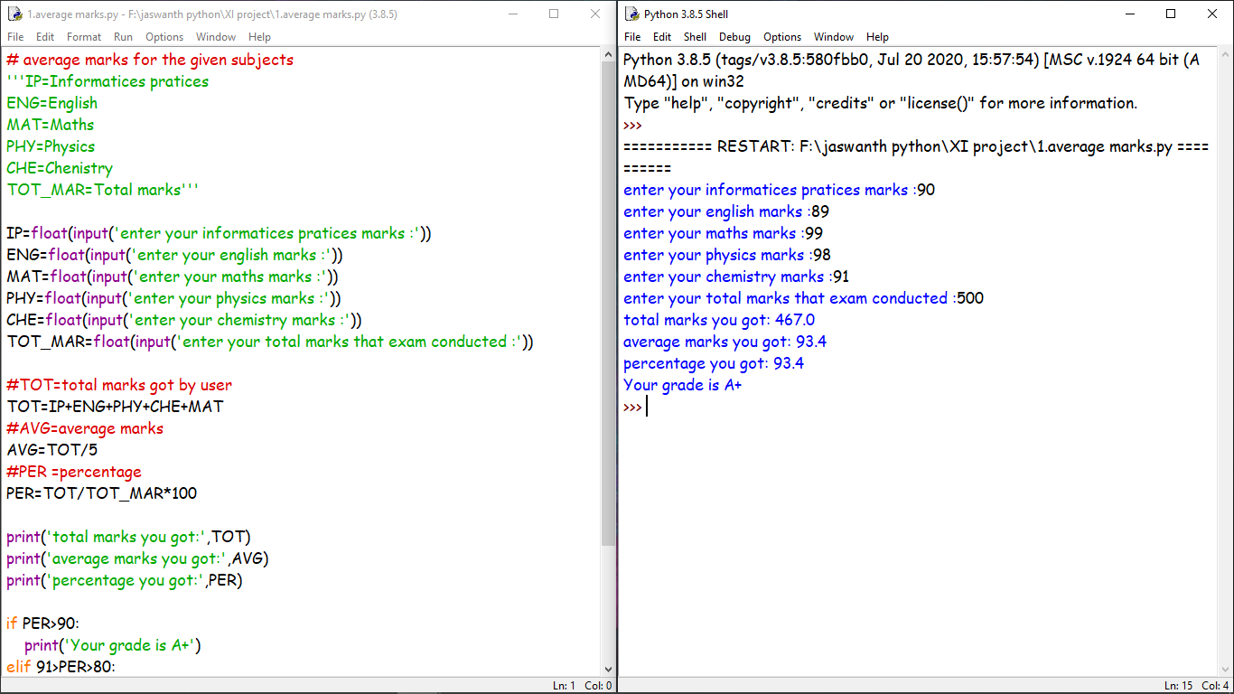

2) To find amount for given cost-qty-discount.

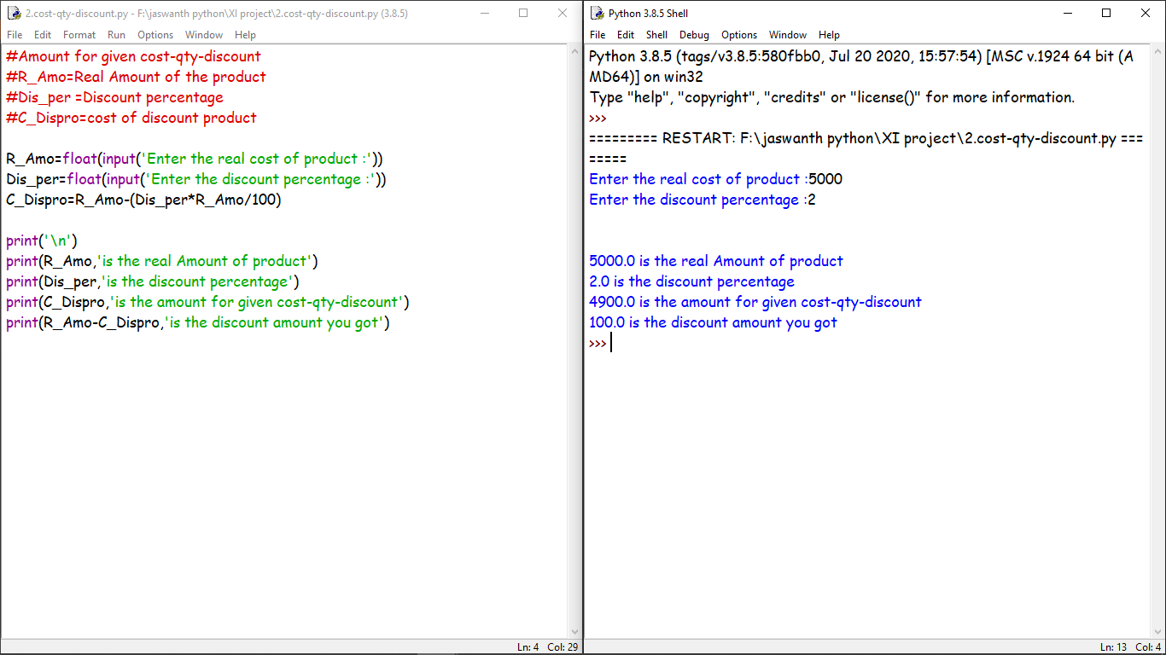

3)To calculate cost perimeter-wise/area-wise.

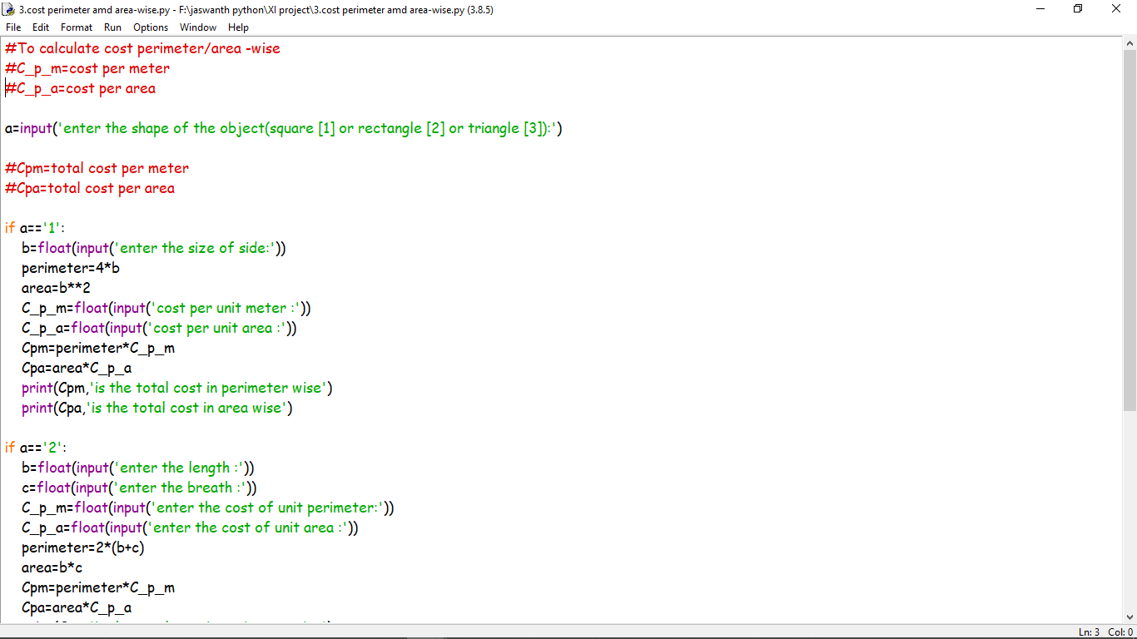

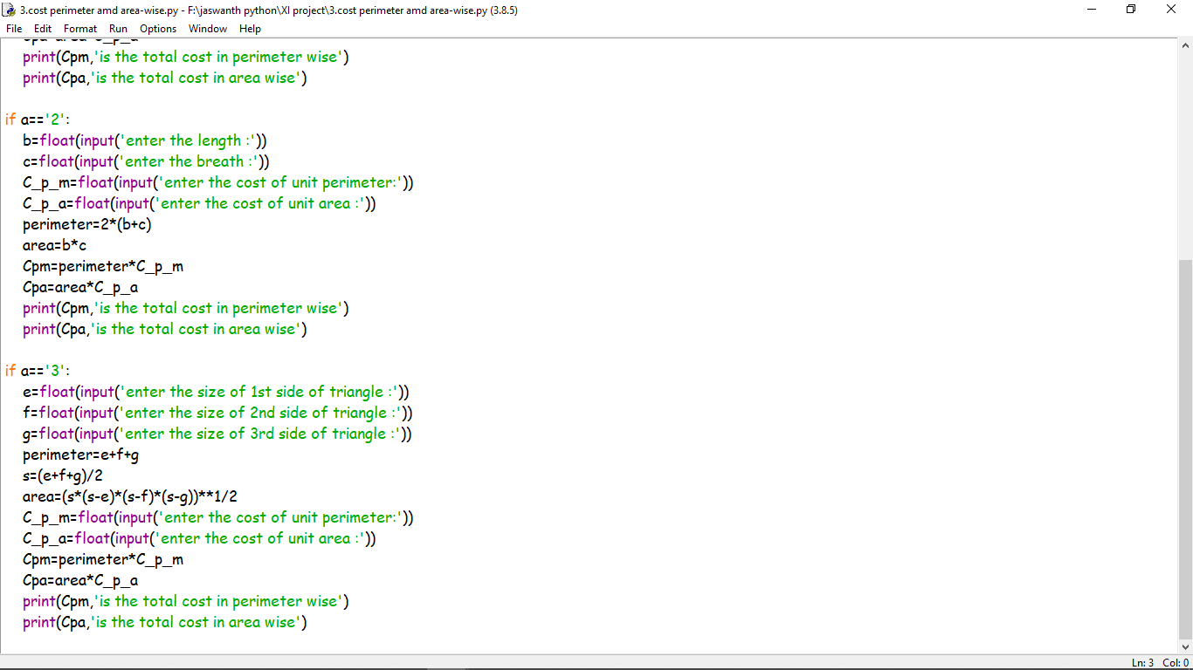

Output: 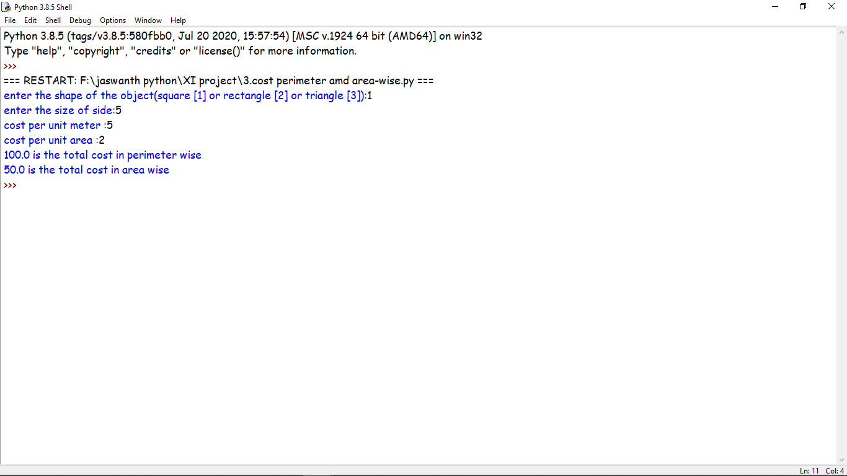

4)To calculate interest(simple and compound).

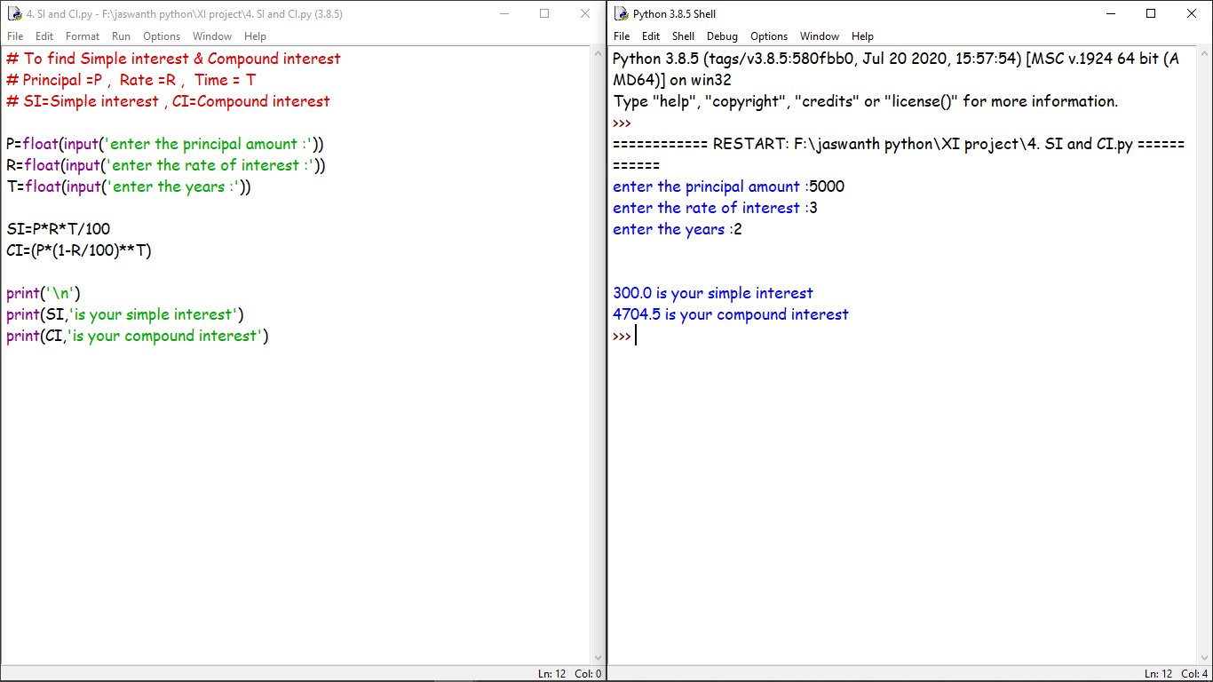

5)To calculate profit-loss for given cost ans sell price.

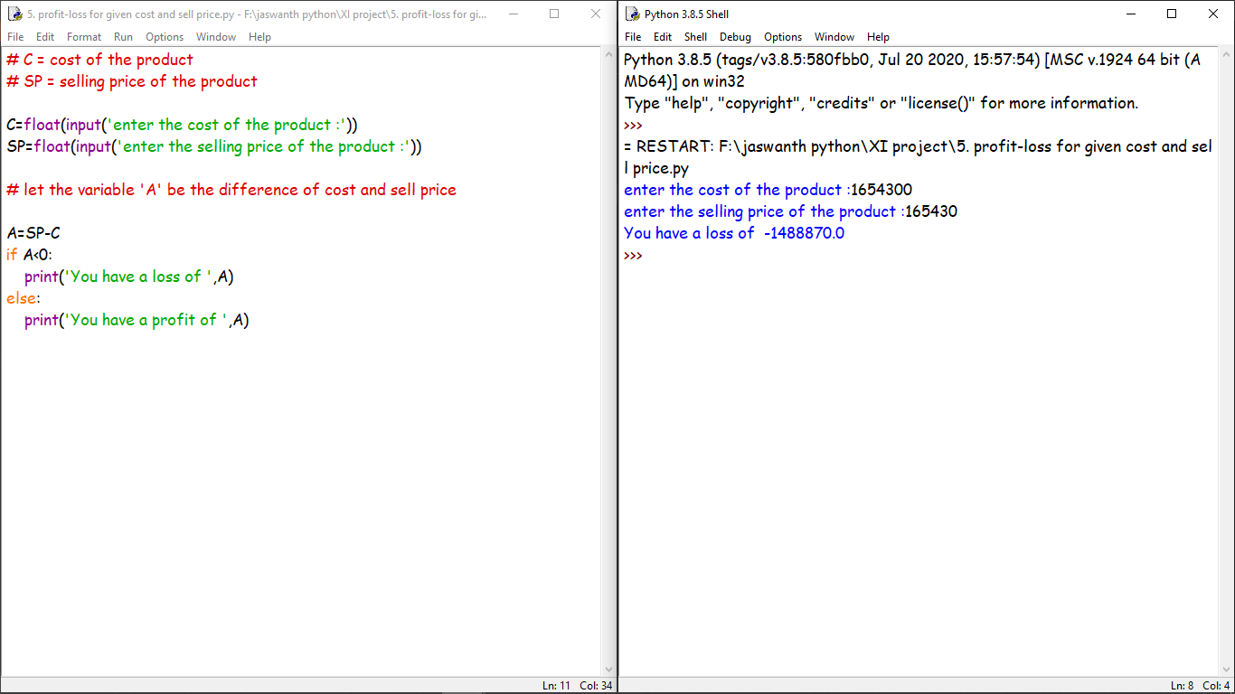

6)To calculate EMI for Amount,Period, and Interest.

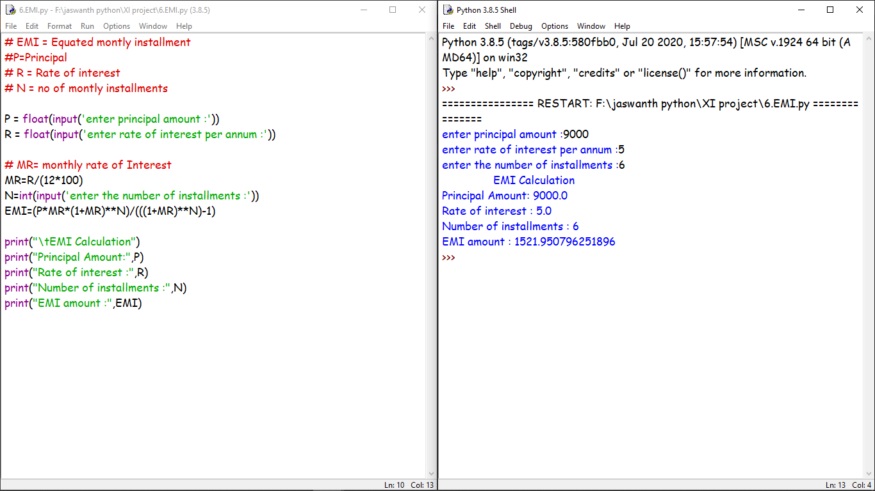

7)To calculate tax (examples from GST/Income Tax).

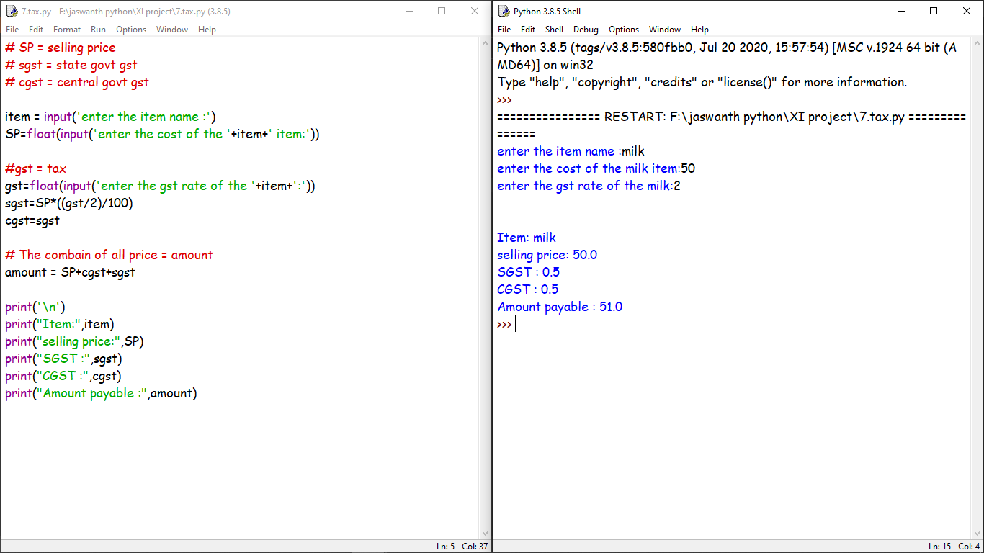

8)To find the largest and smallest number in a list.

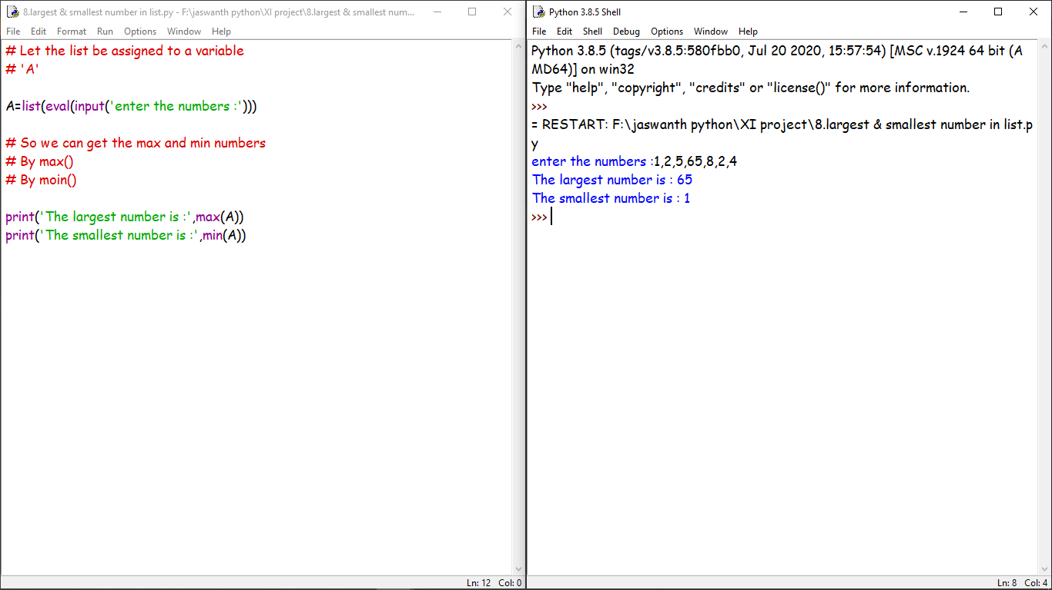

9)To find the third largest number in a list.

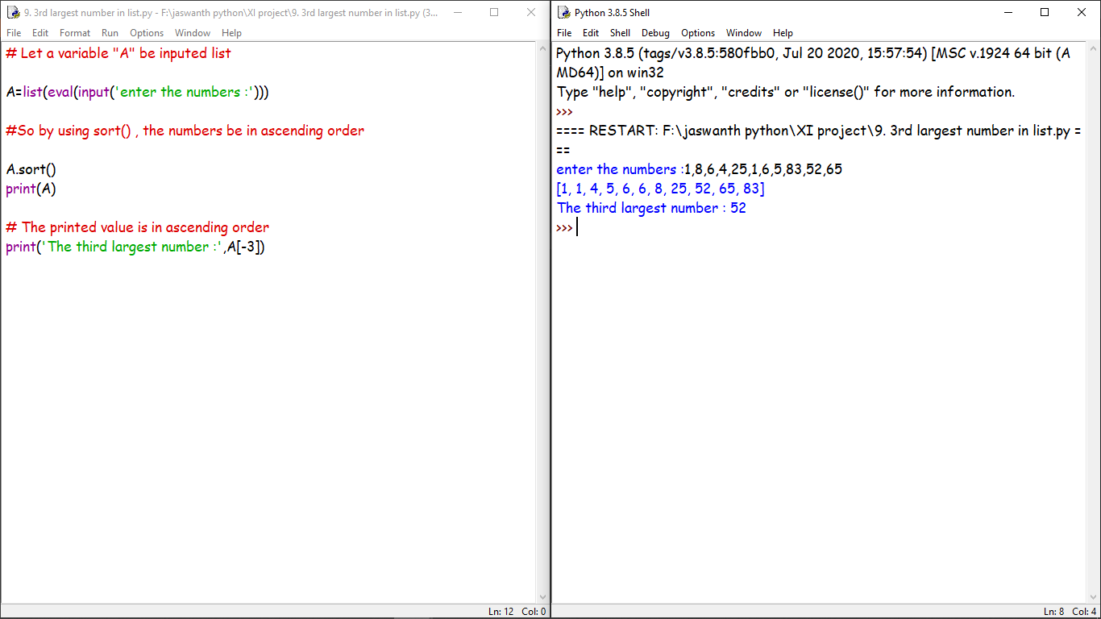

10)To find the sum of squares of the 1st 100 natural numbers.

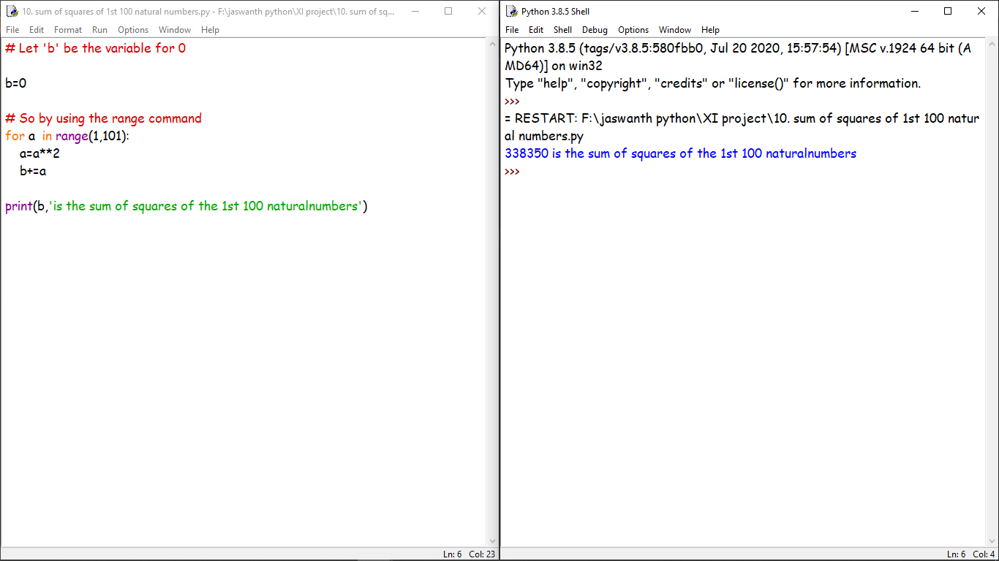

11)To find whether a string is a palindrome or not.

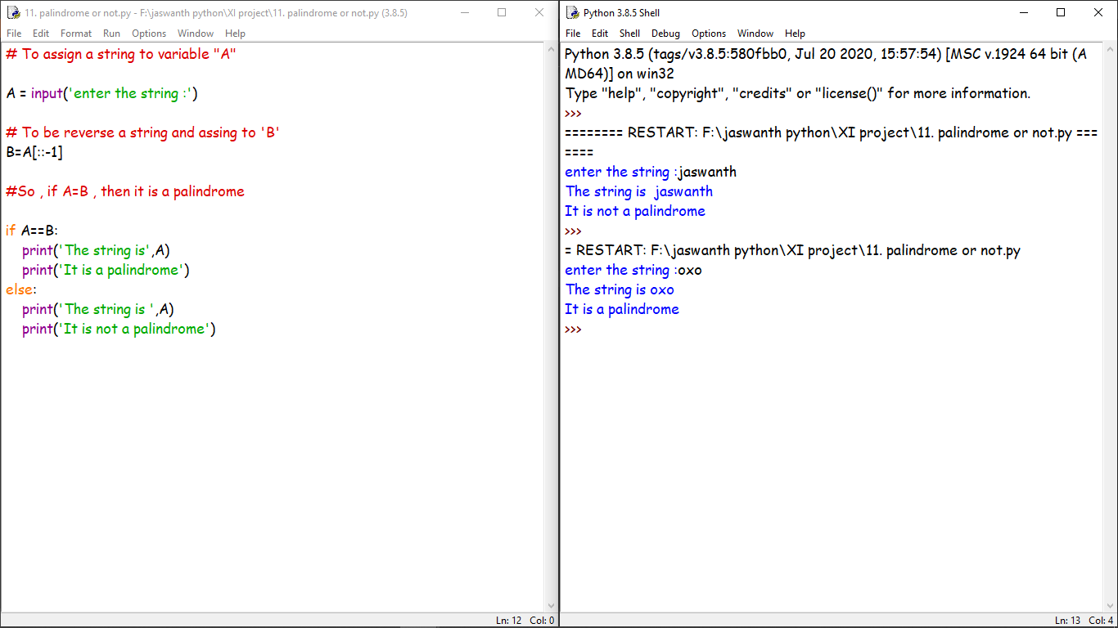

12)To computer x^n ,for given two integers x and n.

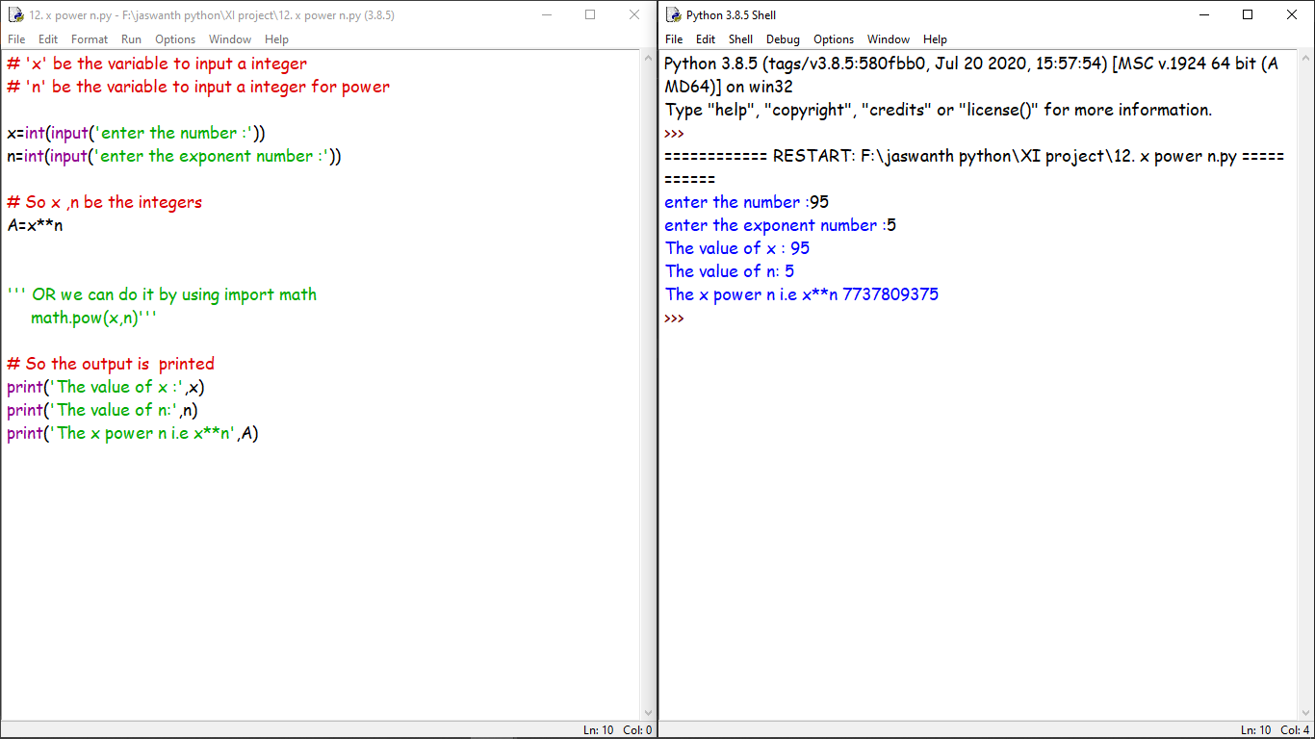

13)Create a dictionary to store names of states and their capitals.

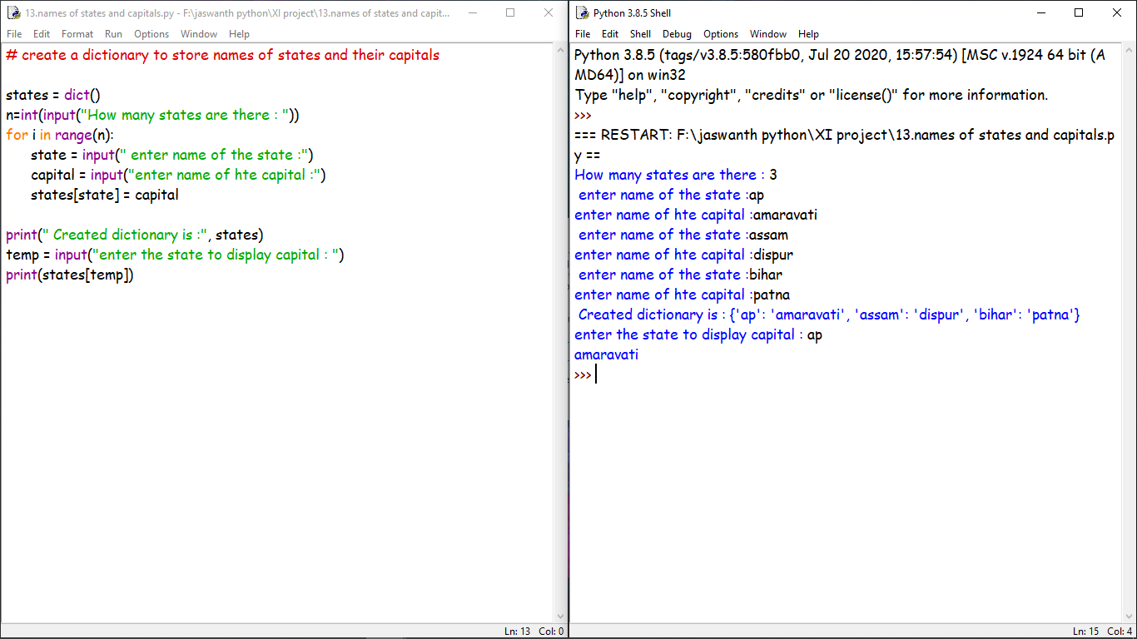

14)create a dictionary of students to store names and marks obtained in 5 subjects.

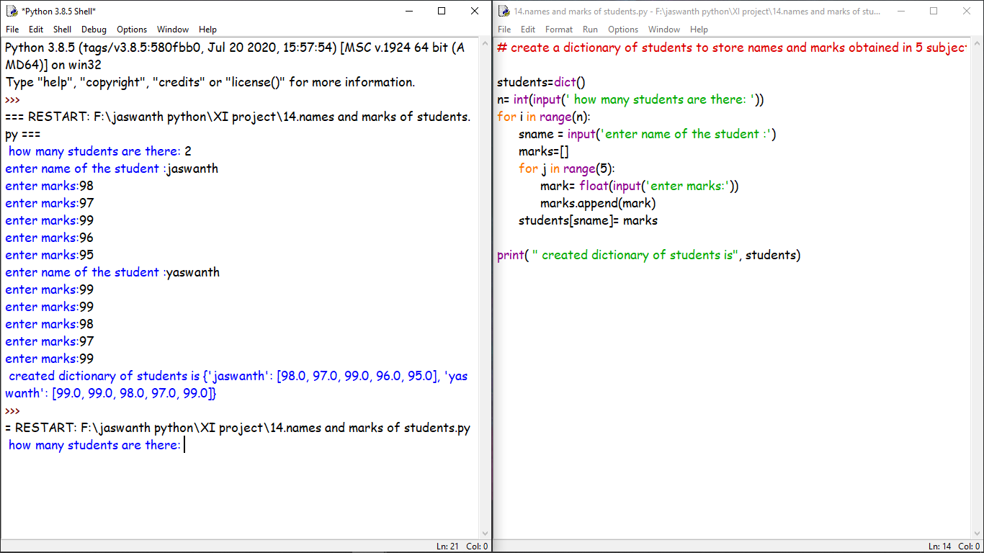

15)To print the highest and lowest values in the dictionary.

